**Assigned Task:**

Simulations of Battery Management System(BMS) on MATLAB.

**Purpose:**

                 To create a prototype initially before trying to replicate a fully functional Autonomous

                vehicle.

**Tools/Software used:**

* <http://www.youtube.com/>, <http://www.coursera.org/>
* MATLAB
* OCTAVE

**Progress:**

Read up quite a number of papers on topics relating to simulation of the BMS system along with videos.Below are the simulations that were carried out. Only the charging simulation(CC-CV) is left to be carried out. Battery swapping also to be implemented wherein the vehicles location and SOC of the battery will be sent to a database once the value of the SOC falls below a threshold, via a Wi-Fi module. The server side then uses the data to find the nearest Battery swapping station and instructs the user to move to that station to swap the Battery. The advantage of this system is that on long journeys, batteries may run out of charge and there may not be charging station available and even if they are they would take a long time to charge but with the battery swapping.

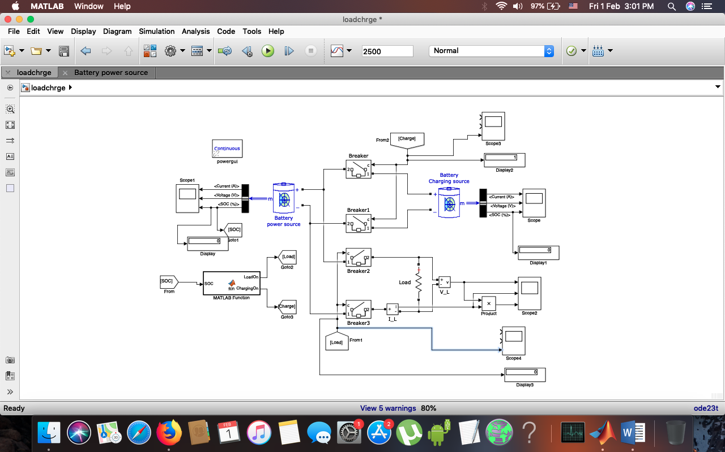

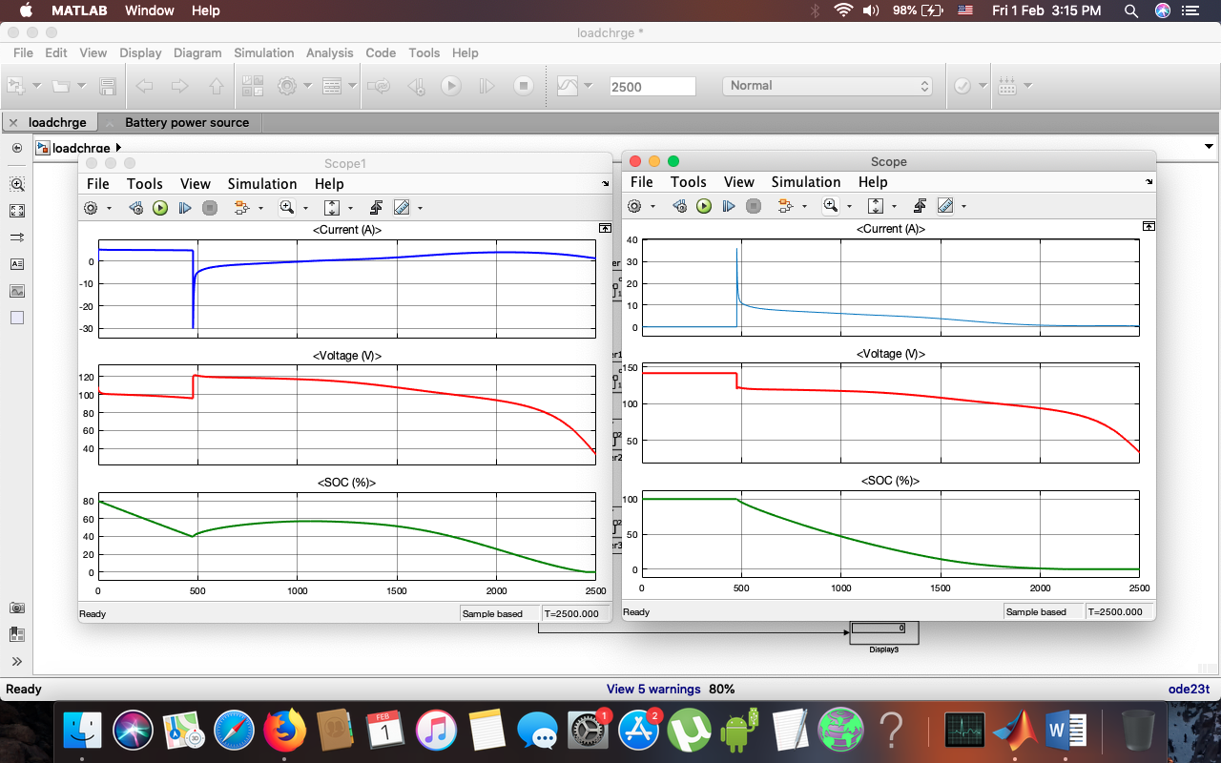

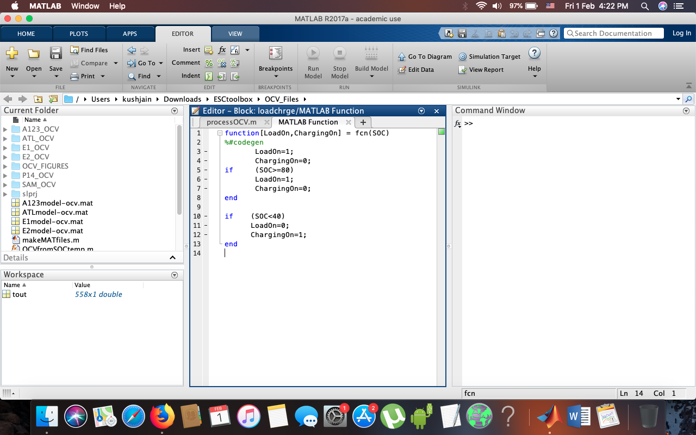

**PAPERS & COURSES**

1. <https://ieeexplore.ieee.org/document/5982950>
2. <https://www.mathworks.com/discovery/battery-management-system.html>
3. <https://www.coursera.org/learn/equivalent-circuit-cell-model-simulation/home/welcome>
4. <http://data.conferenceworld.in/GSMCOE/P248-252.pdf>
5. <https://ieeexplore.ieee.org/document/8242100>
6. <https://ieeexplore.ieee.org/document/5585392>

**YOUTUBE**

1. <https://www.youtube.com/watch?v=OFWCFefmvnM>
2. <https://www.youtube.com/watch?v=QoIV8FNjuEA>

Progress for this sprint: 80%

Issues: Not yet raised

Plan made:

1. Continue with Simulations in the upcoming week to implement the CC-CV charging model in MATLAB.
2. Begin with the Battery swapping algorithms and requirements.

**Prepared By:**

**Kush Jain**